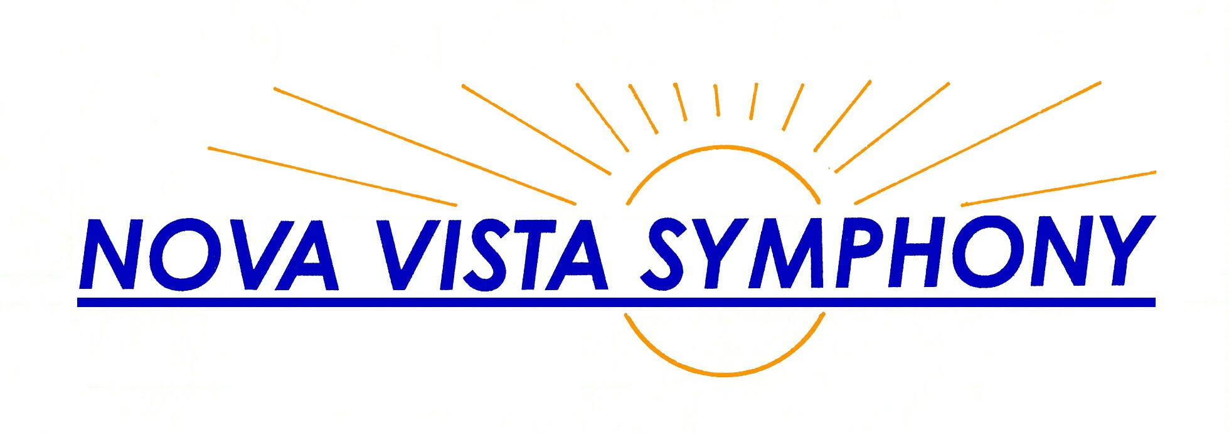  Ann Krinitsky  Music Director  British Brilliance February 17, 2007  William Walton: Portsmouth Point Overture  Ralph Vaughan Williams: Tuba Concerto  Gustav Holst: “Jupiter” from The Planets  Ralph Vaughan Williams: Symphony No. 5  (408) 530-0700 (over for season) www.novavista.org | Ann Krinitsky  Music Director  British Brilliance February 17, 2007  William Walton: Portsmouth Point Overture  Ralph Vaughan Williams: Tuba Concerto  Gustav Holst: “Jupiter” from The Planets  Ralph Vaughan Williams: Symphony No. 5  (408) 530-0700 (over for season) www.novavista.org
Ann Krinitsky  Music Director  British Brilliance February 17, 2007  William Walton: Portsmouth Point Overture  Ralph Vaughan Williams: Tuba Concerto  Gustav Holst: “Jupiter” from The Planets  Ralph Vaughan Williams: Symphony No. 5  (408) 530-0700 (over for season) www.novavista.org | Ann Krinitsky  Music Director  British Brilliance February 17, 2007  William Walton: Portsmouth Point Overture  Ralph Vaughan Williams: Tuba Concerto  Gustav Holst: “Jupiter” from The Planets  Ralph Vaughan Williams: Symphony No. 5  (408) 530-0700 (over for season) www.novavista.org
Ann Krinitsky  Music Director  British Brilliance February 17, 2007  William Walton: Portsmouth Point Overture  Ralph Vaughan Williams: Tuba Concerto  Gustav Holst: “Jupiter” from The Planets  Ralph Vaughan Williams: Symphony No. 5  (408) 530-0700 (over for season) www.novavista.org | Ann Krinitsky  Music Director  British Brilliance February 17, 2007  William Walton: Portsmouth Point Overture  Ralph Vaughan Williams: Tuba Concerto  Gustav Holst: “Jupiter” from The Planets  Ralph Vaughan Williams: Symphony No. 5  (408) 530-0700 (over for season) www.novavista.org
Ann Krinitsky  Music Director  British Brilliance February 17, 2007  William Walton: Portsmouth Point Overture  Ralph Vaughan Williams: Tuba Concerto  Gustav Holst: “Jupiter” from The Planets  Ralph Vaughan Williams: Symphony No. 5  (408) 530-0700 (over for season) www.novavista.org | Ann Krinitsky  Music Director  British Brilliance February 17, 2007  William Walton: Portsmouth Point Overture  Ralph Vaughan Williams: Tuba Concerto  Gustav Holst: “Jupiter” from The Planets  Ralph Vaughan Williams: Symphony No. 5  (408) 530-0700 (over for season) www.novavista.org
Ann Krinitsky  Music Director  British Brilliance February 17, 2007  William Walton: Portsmouth Point Overture  Ralph Vaughan Williams: Tuba Concerto  Gustav Holst: “Jupiter” from The Planets  Ralph Vaughan Williams: Symphony No. 5  (408) 530-0700 (over for season) www.novavista.org | Ann Krinitsky  Music Director  British Brilliance February 17, 2007  William Walton: Portsmouth Point Overture  Ralph Vaughan Williams: Tuba Concerto  Gustav Holst: “Jupiter” from The Planets  Ralph Vaughan Williams: Symphony No. 5  (408) 530-0700 (over for season) www.novavista.org

