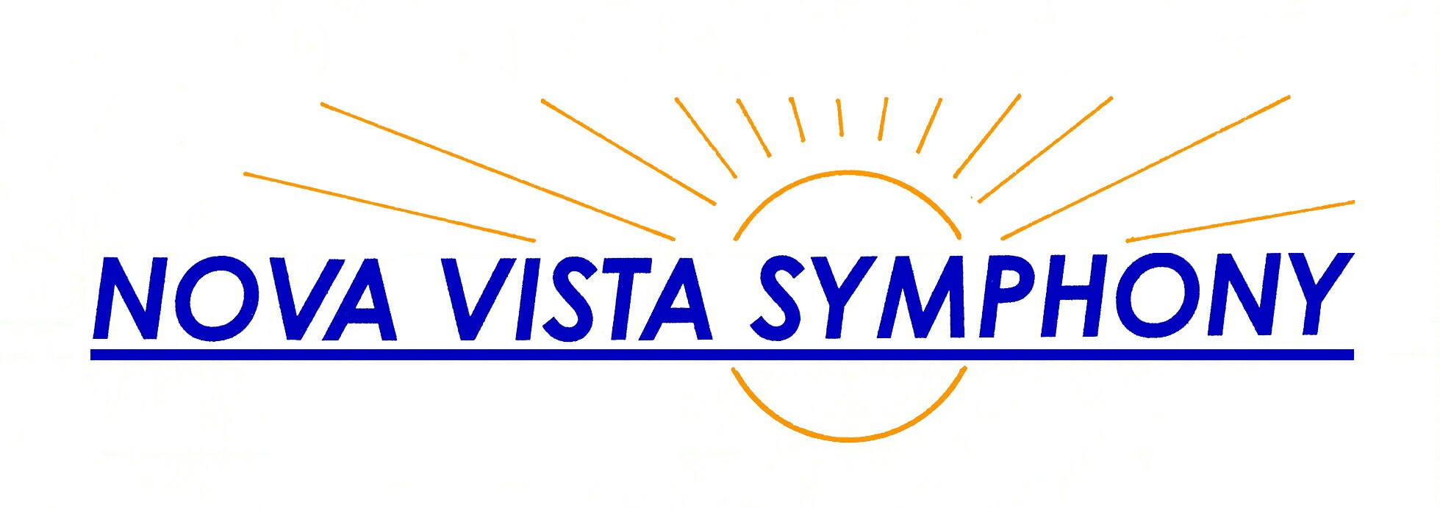  Ann Krinitsky  Music Director  Passion and Nationalism October 28, 2006  Gioacchino Rossini: Barber of Seville Overture  Sergei Rachmaninoff: Piano Concerto No. 3  Antonin Dvorak: Symphony No. 5  (408) 530-0700 (over for season) www.novavista.org | Ann Krinitsky  Music Director  Passion and Nationalism October 28, 2006  Gioacchino Rossini: Barber of Seville Overture  Sergei Rachmaninoff: Piano Concerto No. 3  Antonin Dvorak: Symphony No. 5  (408) 530-0700 (over for season) www.novavista.org
Ann Krinitsky  Music Director  Passion and Nationalism October 28, 2006  Gioacchino Rossini: Barber of Seville Overture  Sergei Rachmaninoff: Piano Concerto No. 3  Antonin Dvorak: Symphony No. 5  (408) 530-0700 (over for season) www.novavista.org | Ann Krinitsky  Music Director  Passion and Nationalism October 28, 2006  Gioacchino Rossini: Barber of Seville Overture  Sergei Rachmaninoff: Piano Concerto No. 3  Antonin Dvorak: Symphony No. 5  (408) 530-0700 (over for season) www.novavista.org
Ann Krinitsky  Music Director  Passion and Nationalism October 28, 2006  Gioacchino Rossini: Barber of Seville Overture  Sergei Rachmaninoff: Piano Concerto No. 3  Antonin Dvorak: Symphony No. 5  (408) 530-0700 (over for season) www.novavista.org | Ann Krinitsky  Music Director  Passion and Nationalism October 28, 2006  Gioacchino Rossini: Barber of Seville Overture  Sergei Rachmaninoff: Piano Concerto No. 3  Antonin Dvorak: Symphony No. 5  (408) 530-0700 (over for season) www.novavista.org
Ann Krinitsky  Music Director  Passion and Nationalism October 28, 2006  Gioacchino Rossini: Barber of Seville Overture  Sergei Rachmaninoff: Piano Concerto No. 3  Antonin Dvorak: Symphony No. 5  (408) 530-0700 (over for season) www.novavista.org | Ann Krinitsky  Music Director  Passion and Nationalism October 28, 2006  Gioacchino Rossini: Barber of Seville Overture  Sergei Rachmaninoff: Piano Concerto No. 3  Antonin Dvorak: Symphony No. 5  (408) 530-0700 (over for season) www.novavista.org
Ann Krinitsky  Music Director  Passion and Nationalism October 28, 2006  Gioacchino Rossini: Barber of Seville Overture  Sergei Rachmaninoff: Piano Concerto No. 3  Antonin Dvorak: Symphony No. 5  (408) 530-0700 (over for season) www.novavista.org | Ann Krinitsky  Music Director  Passion and Nationalism October 28, 2006  Gioacchino Rossini: Barber of Seville Overture  Sergei Rachmaninoff: Piano Concerto No. 3  Antonin Dvorak: Symphony No. 5  (408) 530-0700 (over for season) www.novavista.org

