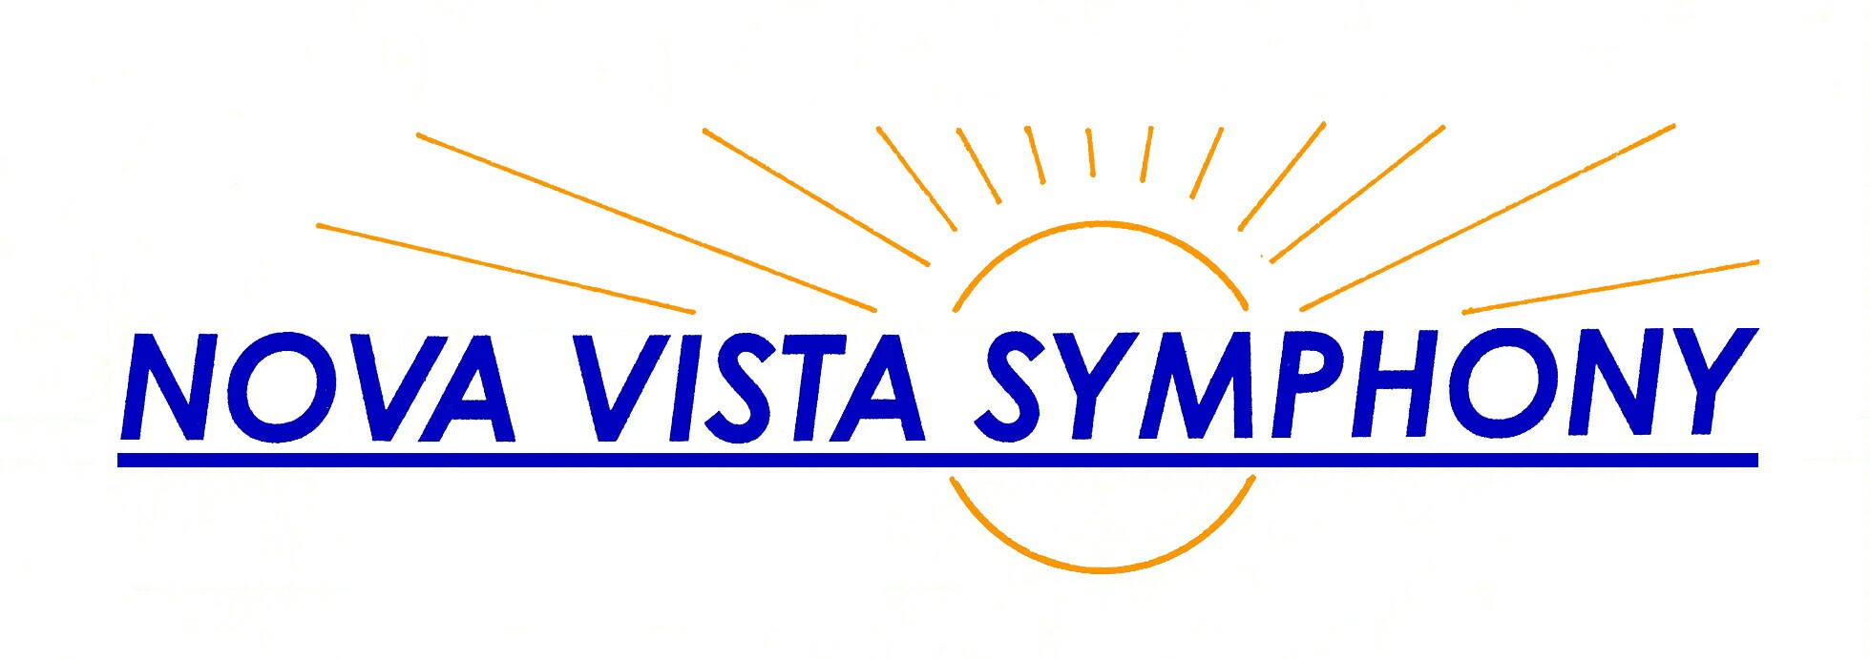  Ann Krinitsky  Music Director  Julia Goldstein  President  Flute/piccolo  (408) 530-0700 (over for season) www.novavista.org | Ann Krinitsky  Music Director  Julia Goldstein  President  Flute/piccolo  (408) 530-0700 (over for season) www.novavista.org
Ann Krinitsky  Music Director  Julia Goldstein  President  Flute/piccolo  (408) 530-0700 (over for season) www.novavista.org | Ann Krinitsky  Music Director  Julia Goldstein  President  Flute/piccolo  (408) 530-0700 (over for season) www.novavista.org
Ann Krinitsky  Music Director  Julia Goldstein  President  Flute/piccolo  (408) 530-0700 (over for season) www.novavista.org | Ann Krinitsky  Music Director  Julia Goldstein  President  Flute/piccolo  (408) 530-0700 (over for season) www.novavista.org
Ann Krinitsky  Music Director  Julia Goldstein  President  Flute/piccolo  (408) 530-0700 (over for season) www.novavista.org | Ann Krinitsky  Music Director  Julia Goldstein  President  Flute/piccolo  (408) 530-0700 (over for season) www.novavista.org
Ann Krinitsky  Music Director  Julia Goldstein  President  Flute/piccolo  (408) 530-0700 (over for season) www.novavista.org | Ann Krinitsky  Music Director  Julia Goldstein  President  Flute/piccolo  (408) 530-0700 (over for season) www.novavista.org

