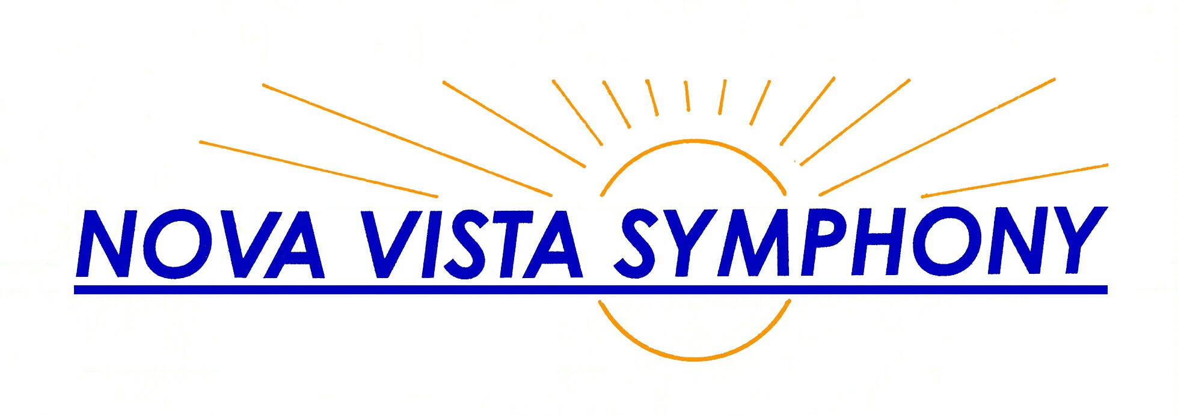  Ann Krinitsky  Music Director  Your Name  Instrument (or title, if board member)  (Instrument, if line above is title, else blank)  (408) 530-0700 (over for season) www.novavista.org | Ann Krinitsky  Music Director  Your Name  Instrument (or title, if board member)  (Instrument, if line above is title, else blank)  (408) 530-0700 (over for season) www.novavista.org
Ann Krinitsky  Music Director  Your Name  Instrument (or title, if board member)  (Instrument, if line above is title, else blank)  (408) 530-0700 (over for season) www.novavista.org | Ann Krinitsky  Music Director  Your Name  Instrument (or title, if board member)  (Instrument, if line above is title, else blank)  (408) 530-0700 (over for season) www.novavista.org
Ann Krinitsky  Music Director  Your Name  Instrument (or title, if board member)  (Instrument, if line above is title, else blank)  (408) 530-0700 (over for season) www.novavista.org | Ann Krinitsky  Music Director  Your Name  Instrument (or title, if board member)  (Instrument, if line above is title, else blank)  (408) 530-0700 (over for season) www.novavista.org
Ann Krinitsky  Music Director  Your Name  Instrument (or title, if board member)  (Instrument, if line above is title, else blank)  (408) 530-0700 (over for season) www.novavista.org | Ann Krinitsky  Music Director  Your Name  Instrument (or title, if board member)  (Instrument, if line above is title, else blank)  (408) 530-0700 (over for season) www.novavista.org
Ann Krinitsky  Music Director  Your Name  Instrument (or title, if board member)  (Instrument, if line above is title, else blank)  (408) 530-0700 (over for season) www.novavista.org | Ann Krinitsky  Music Director  Your Name  Instrument (or title, if board member)  (Instrument, if line above is title, else blank)  (408) 530-0700 (over for season) www.novavista.org

